Teacher Appreciation Week

May 7 – 11, 2018

Next week is Teacher Appreciation week.

There will be a different theme each day – these are simply suggestions.

Feel free to participate when you are able. When you see your teachers, please take the time to say thank you for their hard work and dedication!

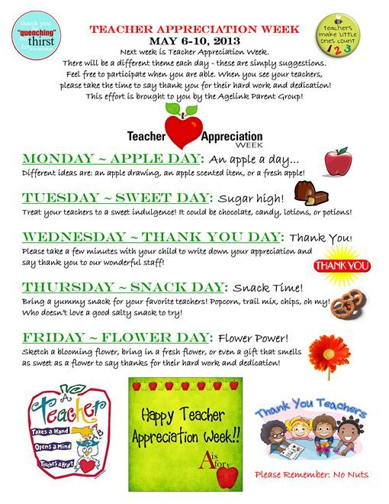

***Monday – Eating healthy Fruit Day:***

*An apple a day…Different ideas are apples, oranges, bananas, any kind of fruit.*

***Tuesday – Sweet Day:***

*Sugar High! Treat your teachers to a sweet indulgence! Please no nuts or homemade items.*

***Wednesday – Thank You Day:***

*Thank you! Please take a few minutes with your child to write down your appreciation and say thank you to our wonderful staff! A hand written note would be appreciated.*

***Thursday – Bloom:***

*Flower Power! Sketch a blooming flower, bring in a fresh flower, or even a gift that smells as sweet as a flower to say thanks for their hard work and dedication!*

***Friday – Pampering:***

*Bring your teacher small gift that makes them feel pampered. Lotion, lip gloss, bubble bath, soap, pedicure, etc.*

*Thank you for all you do to make our first*

*BridgePrep Academy Teacher Appreciation Day Special.*